

INDIAN COUNCIL FOR RESEARCH ON INTERNATIONAL ECONOMIC RELATIONS

Working Paper No. 187

Prospects for IT-Enabled Services Under a Indo-US FTA

Arpita Mukherjee
Paramita Deb Gupta

September 2006
Contents

Abbreviations i
Abstract ii
Foreword iii
Introduction 1
1 Indo-US Trade in ITES/BPO Services 2
2 Multilateral Liberalization in ITES/BPO Services 9
3 Bilateral Liberalization in ITES/BPO Services 12
4 Indo-US FTA: Implications for India 15
4.1 Barriers faced by Indian companies in the US 15
4.2 Barriers faced by the US companies in India 18
4.3 Indo-US FTA Negotiations 20
5 Reforms 22
6 Conclusion 24
Bibliography 26
Appendix A: Sample Questionnaires 29
Appendix B: List of US State-level Legislations against Outsourcing 48
Appendix C : GATS Framework 51
Appendix D: Comparison between H1B Visa and H1B1 Visa under the US-Singapore and the US-Chile FTAs 53

List of Tables

Table 1.1: Growth in Imports of ‘Other Private Services’ by Region and Selected Countries 3

Table 4.1.1: Visa-related Problems in the US 17

List of Figures

Figure 1.1 : Growth in Total Revenue and Exports of Indian ITES/BPO Sector (FY 2000-2006) 4
Figure 1.2 : ITES/BPO Companies’ Activity by Industry Verticals 5
Figure 1.3 : Advantages of Outsourcing to India 8

Figure 4.1.1 : Data Protection Measures Undertaken by Companies 16

Figure 4.2.1: Problems Faced by the US Companies in India 18

Abbreviations

BEA | Bureau of Economic Analysis
BPO | Business Process Outsourcing
BPT | Business, Professional and Technical Services
CAGR | Compound Annual Growth Rate
CECA | Comprehensive Economic Cooperation Agreement
CEOs | Chief Executive Officers
DHS | Department of Human Services
FDI | Foreign Direct Investment
FTA | Free Trade Agreement
FY | Financial Year
GATS | General Agreement on Trade in Services
GDP | Gross Domestic Product
GPA | Government Procurement Agreement
HR | Human Resource
IDC | International Data Corporation
IPRs | Intellectual Property Rights
IT | Information Technology
ITAA | Information Technology Association of America
ITES | Information Technology Enabled Services
KPO | Knowledge Process Outsourcing
MDs | Managing Directors
MNCs | Multi National Corporations
MRAs | Mutual Recognition Agreements
NAC | NASSCOM Assessment of Competence
NASSCOM | National Association of Software and Service Companies
NCR | National Capital Region
NFAP | National Foundation for American Policy
OPS | Other Private Services
R&D | Research and Development
SEBs | State Electricity Boards
SMU | Sikkim Manipal University
STPI | Software Technology Park in India
T&D | Transmission and Distribution
UPS | Uninterrupted Power Supply
US | United States of America
NAMA | Non-Agriculture Market Access
WTO | World Trade Organization
Y2K | Year 2000

Abstract

ITES/BPO services is an important and growing component of India’s trade in
services with the US. While the Indian government has implemented several measures to support the growth of this sector, Indian companies face various barriers in the US market such as anti-outsourcing regulations, restrictive visa/work permit regime and concerns relating to protection of sensitive data. Multilateral negotiations would have been the best route to address many of these barriers, but with the recent suspension of the Doha Round of talks, it has become important for countries to evaluate alternative routes such as bilateral Free Trade Agreements. In fact, after the suspension of the multilateral negotiations, both India and the US have refocused on bilateral agreements. In this context, this study discusses the current and potential trade between India and the US in ITES/BPO services, identifies barriers to trade and explores how an FTA can enhance bilateral trade in this sector.

The study shows that the US-FTAs have achieved a higher level of liberalization than in the WTO. It suggests various negotiating strategies for India such as a negative list approach, signing mutual recognition agreements in key professional services, asking for a H1B1 type of visa, pushing for removal of domestic regulation-related barriers, among others which would enhance market access for Indian companies in the US. It also points out that Indo-US collaborations for data protection, skill development and raising awareness of the advantages of outsourcing in the US would be mutually beneficial. The study discusses regulatory and other reforms which will improve the productivity, efficiency and global competitiveness of this sector and enable the country to gain from the FTA.

JEL Classification: F13, F14, L86
Keywords: Indo-US FTA, GATS, Bilateral Agreements, business process outsourcing, IT-enabled services.

Foreword

This paper is a part of the study undertaken by ICRIER on “Indo-US Trade in Services: Prospects for the Information Communication Technology sector under a Possible Free Trade Agreement” for NASSCOM. The study, based on a survey of 112 companies, analyzes the current trade between India and the US in ITES/BPO sector, identifies the trade barriers and suggests how these can be addressed if the two countries enter into an FTA.

The US is India’s major trading partner and Indian companies are facing several barriers in the US market. With the suspension of the Doha Round of talks, it has become difficult for India to raise these issues multilaterally. India and other WTO member countries are now focusing on bilateral/regional agreements. In this context, this study is very timely. I am confident that this paper will provide significant input to policy makers, negotiators, industry associations and academicians working towards realizing the potential of this sector.

Rajiv Kumar
Director and Chief Executive

September 26, 2006

Prospects for IT-Enabled Services
under a Indo-US FTA*

Introduction

In the recent years, a large number of services are outsourced from the developed to the developing countries, in particular from the US to India. Although cross border trade in ITES/BPO services started receiving global attention in a big way only in the past ten years or so, it is not entirely a new concept. In fact, its origin can be traced back to over two decades ago, when multinationals from developed countries, such as the US and Japan, started setting up manufacturing units in low-wage countries to take advantage of wage differentials and then exported the finished goods back to the home market. With increased globalization, development of IT (Information Technology), innovation in business practices, certain services were relocated initially within the country to low-cost areas and later to countries with low-cost and high-skilled manpower. Today, this is one of the fastest growing areas of international trade. According to International Data Corporation (IDC), worldwide spending on BPO services is expected to grow at the compound annual rate of 11 per cent from US $712 billion in 2001 to US $1.2 trillion in 2006.

The US is the leader among the developed countries which outsource services to the developing world. Since the 1990s, India has created a niche for itself as a major exporter of knowledge-based services including software services. With a huge pool of English-speaking skilled-manpower available at competitive prices, India has become an important destination for outsourcing. The US is the main export destination for Indian companies and around two-thirds of their exports are to the US. Hence, both India and the US have trade complementarities in this sector.

With the suspension of the WTO (World Trade Organization) negotiations on 24 July 2006, both India and the US have renewed their focus on entering into FTAs (Free Trade Agreements) with like-minded trading partners. In the past, the two countries had expressed a keen interest in strengthening their trade links by entering into an FTA. While the Indian side was pushing for an FTA in services, the US wanted a comprehensive FTA which would include goods, services, investment and trade facilitation among others. Although the exact structure of the FTA is yet to be decided, a large number of studies, such as Panagariya (2004), Lawrence and Chadha (2004), and Roy and Banerjee (2004), have identified areas of trade complementarities. They all indicated that ITES is one of the priority areas for India in the proposed FTA negotiations. The need to negotiate bilaterally to remove trade barriers is particularly pertinent in the present situation where many US states have enacted or are in the process of enacting anti-outsourcing regulations, primarily to protect jobs in their domestic industries. Moreover, the temporary suspension of Doha Round has slowed down the process of addressing these barriers through multilateral negotiations.

This paper discusses the current trade between India and the US in ITES/BPO services and explores the ways in which the FTA can enhance bilateral trade in this sector. The structure of the paper is as follows: Section 1 discusses the current and potential trade between India and the US in ITES/BPO services. Section 2 examines the multilateral liberalization in this sector. Section 3 highlights how far the sector has been liberalized in some key US-FTAs and in the Indo-Singapore CECA (Comprehensive Economic Cooperation Agreement). Section 4 discusses the barriers faced by the Indian and US companies in each others’ markets. It also presents India’s possible negotiating strategies, emphasizing on the demand that India can make during the negotiations and India’s possible response to the US demands. Section 5 lists the domestic reforms which would improve productivity, efficiency and global competitiveness of the sector and enable India to gain from the bilateral liberalization. The last section draws the main conclusions.

Indo-US Trade in ITES/BPO Services

Trade in ITES/BPO services between India and the US owes its success to the Indian software industry, which established a global reputation in the 1990s during the Y2K burst. The offshoring of software services gradually led to business process outsourcing. In the mid-1990s, the US companies such as American Express and General Electric established captive units in India to provide customer support and transaction processing services. Successful operation of captive BPOs led to emergence of independent BPOs and entry of software companies into the BPO segment, either directly or through mergers and acquisitions.

It is very difficult to find data on trade in ITES/BPO services because of the nature of these services which cuts across different sectors. The US Bureau of Economic Analysis (BEA) provides data on the US cross-border trade in services. BEA does not have a specific category for ITES/BPO services and it is included in the category – ‘Business, Professional and Technical Services’ (BPT) under ‘Other Private Services’ (OPS). BEA does not have the latest country-wise data on import of BPT services due to the lack of availability of data from all trading partners. The growth in the US imports of ‘Other Private Services’ by region and selected countries is given in Table 1.1. Table 1.1 shows that the average annual growth rate in import of ‘Other Private Services’ from India was around 23 per cent in 1992-2003, which is the fastest growth rate in the Asia-Pacific region. As is clearly evident, India is gradually becoming a major trading partner for the US in the ITES/BPO sector. However, in absolute terms, India still lags behind traditional sources of imports of the US in the Asia and Pacific region, such as Japan and Hong Kong. Hence, the country needs to maintain its growth momentum to acquire a dominant position.

Table 1.1: Growth in Imports of ‘Other Private Services’ by Region and Selected Countries

 | Average annual rate of change (1992-2003) (per cent) | Imports in 2003  (billions of dollars)
All Countries | 11.8 | 85.8
Canada | 10.7 | 7.9
Europe | 12.2 | 42.2
Latin America & Other Western Hemisphere | 15.7 | 22.4
Africa | 11.3 | 1.0
Middle East | 7.2 | 1.2
Asia & Pacific  Of which: | 7.6 | 11.1
China | 14.0 | 0.5
Hong Kong | 13.0 | 1.4
India | 22.8 | 1.1
Japan | 2.7 | 3.7
Singapore | 21.7 | 0.8
Taiwan | 4.2 | 0.3
Source: Extracted from Borga and Mann (2004), Table I, Page 40.

In India, NASSCOM provides data on revenue of ITES/BPO services. The growth in total revenue and export revenue of ITES/BPO services between 1999-2000 and 2005-06 is given in Figure 1.1. Exports of ITES/BPO services are increasing at a fast pace from US$ 3.1 billion in the financial year 2004 to US$ 4.6 billion in 2005 and is expected to reach US$ 6.3 billion in 2006. Revenues from export market accounted for nearly 88 per cent of India’s total ITES/BPO revenue in 2005. The US is the main export market accounting for around two-third of the exports.

Figure 1.1 : Growth in Total Revenue and Exports of Indian ITES/BPO Sector (FY 2000-2006)
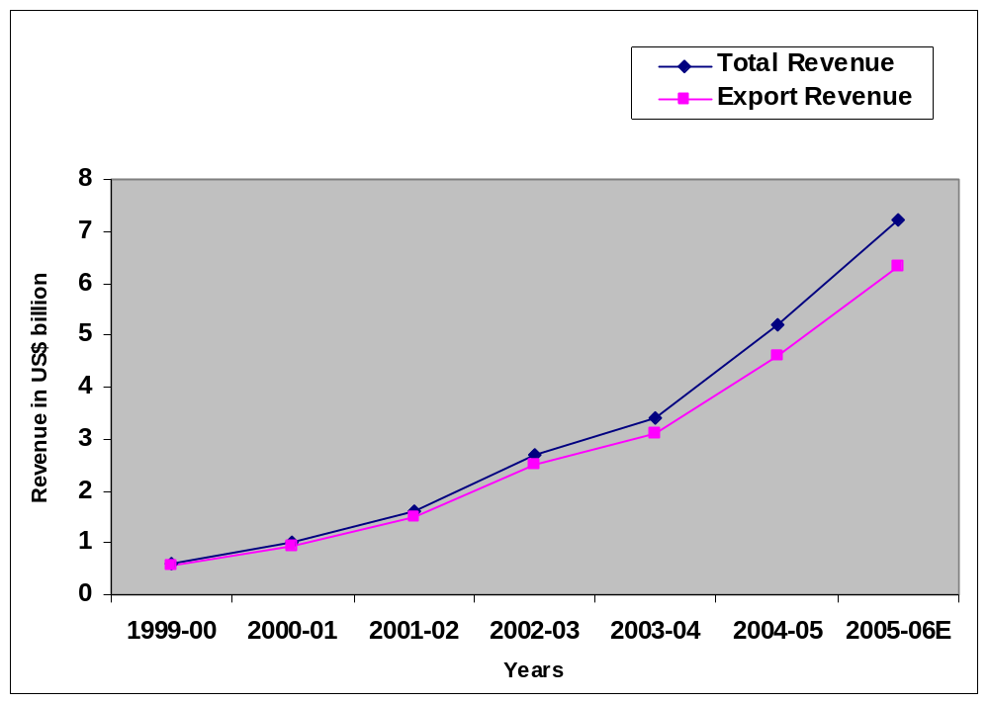
Source: Complied by the authors from NASSCOM, Strategic Review, various years (FY 2000-06)

A survey was carried out to have an understanding of the current and future trade flows between India and the US and, more specifically, to identify the barriers faced by the Indian companies in the US and the US companies in India. The survey also identified what the two countries can demand from each other if there is an FTA. Both NASSCOM and non-NASSCOM member companies were selected for the survey. The survey covered 95 independent BPOs and 17 captive BPOs in NCR (National Capital Region: Delhi, Gurgaon and Noida), Bangalore, Chennai, Mumbai, Hyderabad and Kolkata. For independent BPOs, companies with all or majority business with the US were selected. Only 35 per cent of the independent BPOs exclusively served US clients while the remaining served clients across the globe. Distinction was drawn between small (turnover below $5 Million), medium (between $5 Million to $30 Million) and large (above $30 Million) companies in order to facilitate an understanding of the differences in functioning and requirements of different types of companies.

The survey was based on semi-structured questionnaires. Two sets of questionnaires were designed: one for the US companies having captive units in India and the other for third-party/independent Indian and US BPO units servicing the US clients. The sample questionnaires are enclosed in Appendix A. The use of questionnaires helped to structure the discussion and served as a guiding tool. The interviews were kept partially open-ended to capture as much information as possible and to boost the exploratory nature of the research. Information was collected through repeated on-site visits and interviews were conducted with chief operating officers (CEOs), managing directors (MDs) or senior managers of the companies.

ITES/BPO is a relatively new industry. The survey found that 67 per cent of the independent BPOs started operation after the year 2000, 26 per cent of the companies were formed in the period 1995-2000 and remaining before 1995. The companies that were present before 2000 started growing only after 2000. The Indian ITES/BPO industry is well diversified offering a wide range of services to US clients. Most of the companies surveyed operate in more than one industry verticals as shown in Figure 1.2. Financial services sector is the largest vertical with 67 per cent of the BPO companies serving this sector, followed by the telecommunication sector (35 per cent) and computer equipment and IT (35 per cent). By service line, customer care is the largest segment (62 per cent) followed by finance (54 per cent), content development (26 per cent), administration (25 per cent), payment services (23 per cent), etc.

Figure 1.2 : ITES/BPO Companies’ Activity by Industry Verticals
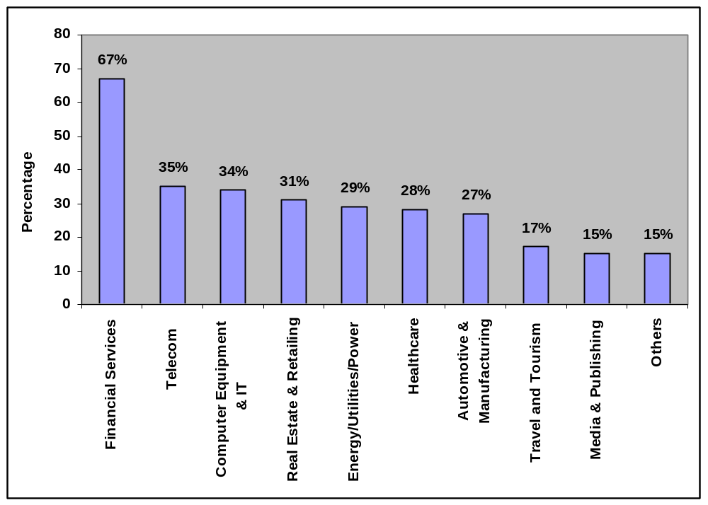
Source: Survey Findings
Notes: (1) Total number of respondents-112: Independent BPOs-95, Captive BPOs-17
(2) Percentages add up to more than 100 because some companies are servicing more than one vertical.

Independent BPOs stated various reasons for venturing into this sector. The two main reasons are growing business potential and better profit margins. For software companies, branching into BPO services was a natural progression since many of their clients demanded total outsourcing solutions. Also, recession in the IT sector in the year 2000 and need to diversify have been given as reasons for software companies to enter into this sector. The survey found that while some software companies have established their own BPO operations, others acquired their BPO operations through mergers and acquisitions (for example, Wipro Technologies Limited has taken over Spectramind e-Services Private Limited).

Around 60 per cent of the turnover of large independent BPOs is generated from the US market. The medium and small-sized companies are more dependent on the US market and almost 95-100 per cent of their turnover is from the US. As the scale of operation increased, some companies diversified across countries. The Indian captive units of the US companies account for a major portion of the revenues (ranging between 50-90 per cent) of their global BPO operations.

Independent BPOs get their business from the US through various means such as dedicated sales and marketing team, business contacts of the parent software companies and through associates or partners in the US. Fifty-five per cent pointed out that Indians employed in the US companies play an important role in getting business for ITES/BPO companies in India. Independent BPOs pointed out that they maintain a very close relationship with their clients. Sixty two per cent of the companies said that their clients play an important role in selecting the employees, especially at the senior management level.

When asked about the strengths of other international BPO locations, around 85 per cent of the respondents felt that Philippines is a major competitor followed by countries such as China, Malaysia, and Ireland. Both independent and captive BPOs pointed out that India has a distinct advantage over China in terms of availability of English-speaking manpower. Although other countries such as Malaysia and Philippines also have English speaking workforce, the numbers are far below the Indian workforce. The size of the workforce and computer literacy is the biggest advantage of India vis-à-vis other countries. However, some captive and independent BPOs pointed out that attrition rates are lower in countries such as Philippines and China than in India.

During the survey, 92 per cent of the respondents felt that Indo-US trade would continue to grow in the future. Not only big US companies, even small and medium-sized companies are looking at the option of outsourcing certain services to countries such as India. More and more Indian companies are moving up in the value chain from voice-based services to non-voice processes. Within non-voice based services, companies are moving from low-end services such as data conversion to high-end services such as data analysis and reporting. Knowledge Process Outsourcing (KPO) would be an important component of trade in the future. Companies are looking into new areas such as legal transcriptions, engineering design and animation and are diversifying into different industry verticals such as healthcare, pharmaceuticals, biotechnology and engineering. This is likely to increase the export revenue and profit margins as billing rates of KPOs are significantly higher than that of traditional BPOs.

The US independent and captive BPOs are planning to scale up their India operations by increasing the size of workforce and establishing operations in different locations of India. The study also found that some of the US captive BPOs have become or are planning to become independent BPOs since the cost of running a captive unit is more than that of an independent BPO. It is likely that, in future, some US companies will follow a dual model where high-end outsourcing such as Research and Development (R&D) will be through captive units while low-end services will be through the independent third-party BPOs.

The survey found that some Indian ITES/BPO companies are acquiring companies in the US and other locations to service the US clients. For instance, ICICI One Source Limited has acquired Account Solutions Group LLC, a New York-based consumer collection agency. Such acquisitions are enabling the Indian companies to access new technology, skill and wider client base.

Various surveys conducted within the US (such as Gartner Survey 2003, Capgemini/ IDC survey, 2004) show that outsourcing would continue to be a part of key business strategy of American companies and more and more organizations are exploring BPO as a strategic option to improve performance. Our survey also authenticates this. As shown in Figure 1.3, there are significant gains from outsourcing to India. The main benefit of outsourcing is the reduction in costs. Pressure to cut costs and shrinking profits led to outsourcing of work to countries such as India. Savings from outsourcing have enabled the US companies to grow. For instance, Delta Airlines outsourced 1,000 call-center jobs to India in 2003, leading to a saving of US$ 25 million which enabled the firm to add 1,200 reservation and sales positions in the US. Companies have also gained from improvement in quality of services and enhanced productivity. Survey participants pointed out that they are outsourcing low-end activities so that they can concentrate on their core areas of expertise. Moreover, these jobs are referred to as monotonous and associated with low prestige in the home country but are considered as career opportunities and attractive in receiving countries. As a result, workers in low-wage countries, such as India, often have high level of motivation and efficiency and outperform their counterparts in developed countries. Some other benefits derived from outsourcing are unique time zone differences permitting 24 × 7 services and increasing return on investment.

Figure 1.3 : Advantages of Outsourcing to India
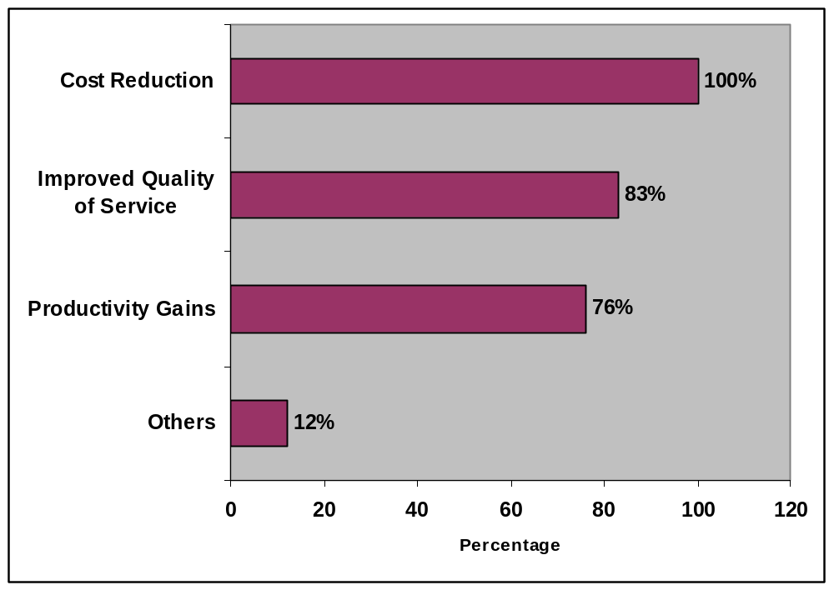
Source: Survey Findings
Notes: (1) Total number of respondents-38: Independent US BPOs- 21, Captive BPOs-17
(2) Percentages add up to more than 100 because some companies have referred
to more than one benefit from offshoring to India.

In India, ITES/BPO sector contribute significantly to the employment and economic growth. In the financial year 2004, 216,000 people were employed in ITES/BPO sector which increased to 316,000 in 2005 and is expected to grow to 409,000 in 2006. The quality of jobs has also improved. Investment by the US independent and captive BPOs is an important source of Foreign Direct Investment (FDI). The sector has contributed to the growth of several ancillary industries (such as transportation, real estate and catering), rise in direct-tax collection and an increase in consumer spending due to the significantly higher disposable incomes of the younger generation.

Indian government (both central and state) has taken proactive steps to support the growth of this sector. To encourage foreign investment, 100 per cent FDI is permitted in ITES/BPO sector. Such companies are allowed to import duty free capital goods and are treated at par with software companies for direct tax exemptions. Call centres and medical transcription centres have been exempted from service tax. Many survey participants were seen availing STPI (Software Technology Parks of India) benefits. At the state-level, governments of some states such as Tamil Nadu, Karnataka, Andhra Pradesh, and West Bengal have formulated separate IT policies to give special incentives to this sector. Some states such as Karnataka and Andhra Pradesh have amended the labour laws to allow women to work in night shifts. The Andhra Pradesh government has also declared this sector as ‘essential services’ forbidding employees from going on strike. There are other state-level incentives such as concessional land and electricity supply at concessional rates.

While the Indian government is taking measures to enhance trade in this sector, in the US, a series of legislation against outsourcing have been introduced in various states. This has been done to prevent job losses due to transfer of jobs to developing countries such as India. Within the first three months of 2005, more than 112 bills to restrict outsourcing were introduced in around 40 states. Out of these, only 12 have become laws. The extent of restrictions proposed by these bills varies. While some aim at restricting outsourcing of personal and financial information, others require call centre location disclosure. Some bills put a complete ban or partial restrictions on outsourcing of federal/state contracts. There are bills which require companies and/or state to collect data on job losses related to outsourcing. Bills have also been initiated to restrict or prohibit receipt of government aid by companies who use overseas contractors and provide tax benefits to companies that locate or remain located in the state. A summary of the state-level anti-outsourcing laws and proposed legislative restrictions has been provided in Appendix B. Although only a few of these bills have become laws, the anti-outsourcing sentiments have received political patronage and wide-spread media coverage. The actual outcome is difficult to predict since more and more US companies are outsourcing as a part of their business strategy, while there is political support for anti-outsourcing movements. Under these circumstances, it is important for India to bilaterally negotiate for removal of barriers to trade in this sector. The next section would discuss how far the sector has been and can be liberalized multilaterally through WTO negotiations.

Multilateral Liberalization in ITES/BPO Services

The Uruguay Round (1986–94) of the WTO negotiations introduced services for the first time into the multilateral trading system. The General Agreement on Trade in Services (GATS), which came into force on 1 January, 1995, envisages progressive liberalization of trade and investment in services through periodic rounds of negotiations. GATS classify services trade under four different modes: Mode 1 (cross-border supply), Mode 2 (consumption abroad), Mode 3 (commercial presence), and Mode 4 (presence of natural persons). The broad framework of GATS is given in Appendix C.

A unique feature of the GATS is that it explicitly includes cross-border trade as a mode of supplying services (Mode 1). It provides a framework for countries to negotiate greater market access and push for removal of discriminatory barriers against foreign service providers (national treatment restrictions). It however, suffers from some shortcomings. The first major difficulty in multilaterally negotiating greater market access in ITES/BPO sector is that all BPO services do not fit into the Services Sectoral Classification List (MTN.GNS/W/120) which was drawn up during the Uruguay Round for the purpose of negotiations. This list was based on United Nations Central Product Classification, which itself has undergone several modifications. Many ITES services, such as payroll or customer care services where Indian companies have competence, do not have a corresponding entry in the W/120.

Negotiating greater market access in ITES/BPO services is complex due to the cross-sectoral nature of such services. GATS follows a positive list approach which gives countries the flexibility to choose the sectors/sub-sectors and modes within those sectors/sub-sectors for making commitments. During the Uruguay Round, only 30 per cent of WTO members undertook full commitments in Mode 1. Many left it “unbound due to the lack of technical feasibility”. In fact, certain services, such as maintenance services, which were not possible to offer electronically during the Uruguay Round is now possible due to technological developments. Many countries expressed reservations to offer liberalization commitments in Mode 1 in regulated sectors such as financial and professional services. Commitments were much more liberal for Mode 2 (50 per cent undertook commitments) than for Mode 1. Although commitments in Mode 1 has improved in the initial and revised offers in the Doha Round, positive listing of sectors makes it difficult to ensure full coverage of a country’s export interests by the commitments undertaken by trading partners.

The WTO E-commerce Work Programme has largely focused on duty-free e-commerce, whereby members have agreed to refrain from imposing custom duties on electronically delivered products. However, little attention has been given to other instruments such as prohibition of foreign supply and discriminatory domestic regulations. With the Internet increasingly being used to provided services such as tele-medicine, distance learning and database management that have traditionally been supplied and regulated on a national basis, domestic regulations (such as data protection laws) can impose barriers to trade in this sector. In fact, many of the barriers imposed by the US are related to domestic regulation. GATS Article VI.4 states that the Council of Trade in Services should develop necessary disciplines to ensure that measures relating to qualification requirements and procedures, technical standards, and licensing requirements do not constitute unnecessary barriers to trade. There is on-going work in the WTO in this regard and the Hong Kong Ministerial Declaration urged WTO members to develop disciplines on domestic regulation pursuant to the mandate under Article VI.4 before the end of current round. However, the progress on developing such discipline was slow until the suspension of this Round.

GATS covers all services except those supplied in the exercise of government authority. Article XIII of GATS states that there shall be multilateral negotiations on government procurement in services under this Agreement within two years from the date of entry into force of the WTO Agreement. However, such agreement is yet to be reached. In the WTO, there is a plurilateral Government Procurement Agreement (GPA) and the US is a party to that agreement. A study by National Foundation for American Policy (NFAP) pointed out that prohibition on state contract work being performed overseas violates the US obligations under the GPA since this agreement prohibits state and federal procurement policies from discriminating on the basis of where work would be performed. It is important to note that the GPA does not explicitly cover BPO and hence there is much room for interpretation. India is not a member of the GPA. Moreover, the agreement is only applicable where the country has made commitments. Since many of the restrictions against offshoring that the US has imposed/is proposing to impose are related to government contracts and GATS does not cover services supplied in the exercise of government authority, India cannot raise them in the WTO.

In the Uruguay Round, neither developed nor developing countries showed much resistance or support for enhancing trade in Mode 1. This situation, however, changed in the Doha Round when some developed countries including the US became protectionist with regard to Mode 1 liberalization while countries such as India focused on greater market access in this mode. On 28 June 2004, India along with Chile and Mexico submitted a proposal for liberalizing Mode 1. The proposal called for locking in the current liberal regime in Modes 1 and 2 to prevent future protectionist actions. In line with this proposal, India requested its trading partners to undertake full commitments in Modes 1 and 2 except for certain sensitive sectors such as financial services. In its revised offers, the US made commitments in Modes 1 and 2 in most sectors except for some such as R&D services, medical and dental services and services relating to manpower consulting, where India has an export interest. If one lists the number of sectors in which the US and India offered full commitments in Modes 1 and 2 in their respective revised offers, the US offers are better than India’s revised offer submitted in August 2005.

The Hong Kong Ministerial Declaration of December 2005 emphasized on the need to expedite negotiations in services. The Annex C of Hong Kong Ministerial Declaration pointed out that in order to achieve a higher level of liberalization, members should undertake commitments at the existing level of market access on a non-discriminatory basis across sectors of interest to trading partners for Modes 1 and 2. It also requested members to remove the existing requirement of commercial presence for offering services under Modes 1 and 2. To expedite the negotiations, in addition to the request-offer approach, members can enter into plurilateral negotiations in accordance with the principle of GATS and the Guidelines and Procedures for Negotiations on Trade in Services. The timeline for submitting the plurilateral request was 28 February 2006 and the time line for submitting revised offers was 31 July 2006. India coordinated the plurilateral request in Modes 1 and 2 which was submitted along with countries such as Chile, Mexico, Pakistan, Singapore and Switzerland. The request has been made to both developing and developed countries including the US. In the plurilateral request, the requesting group of countries provided a list of sectors/sub-sectors in which they would want their trading partners to undertake full market access and national treatment commitments. Some of the sectors, such as R&D services, medical and dental services and services relating to manpower consulting, in which the US did not make any commitments in the revised offers, are in the list. In the plurilateral request, commitments are sought at two-digit level for certain sectors such as computer-related services to take into account technological developments. Members have been requested to make commitments in such as way that it reflects commercially meaningful opportunities. Overall, the plurilateral request attempts to address some key concerns relating to cross-border trade such as a broader sectoral coverage and foreseeing future service activities.

There are linkages between different modes of trade in services. Trade in Mode 1 is affected by barriers to temporary entry of professionals (Mode 4). Since the beginning of Doha Round, India is pushing for greater market access in Mode 4. India is the coordinator of plurilateral request in Mode 4 while the US is a recipient. During the two rounds of plurilateral negotiations, the US expressed reservations in offering liberalization commitments in both Modes 1 and 4.

The Doha Round of negotiations were temporarily suspended on 24 July 2006 after the talks on agriculture (market access and domestic support) and NAMA (Non-Agriculture Market Access) between the six major members - Australia, Brazil, the European Union, India, Japan and the United States broke down on 23 July 2006. Hence, the revised offers were not tabled on 31 July 2006. It is likely that it would take sometime for the services negotiations to begin and gain momentum. In the meanwhile, countries have started focusing more on bilateral and regional agreements. Thus, as of date the scope for removal of barriers to trade in ITES/BPO services in the US market through multilateral negotiations is limited.

The next section discusses the extent to which the sector has been liberalized in some of the US-FTAs and in the Indo-Singapore CECA.

Bilateral Liberalization in ITES/BPO Services

The failure of the Uruguay Round to achieve meaningful liberalization and the slow progress of the Doha Round of negotiations have prompted WTO member countries to enter into bilateral/regional agreements with like-minded trading partners to improve/enhance the speed of liberalization. In the past few years, the US has signed several bilateral agreements – both with developed and developing countries, and is in the process of negotiating with many others. India, too, is in the process of negotiating bilateral/preferential/regional agreements and has signed the Indo-Singapore CECA on 29 June 2005. These agreements are in the form of ‘New Age FTAs’ which goes beyond merchandise trade liberalization to encompass liberalization of services trade and investment among others. Three US-FTAs (US-Chile signed in December 2002, US-Singapore signed in February 2003 and US-Australia signed in February 2004) have been studied to understand how ITES/BPO sector has been treated in the US- FTAs.

One of the important differences between GATS and the US-FTAs is that the latter follows a negative list approach. Under this approach, the US and its trading partners have to clearly give reasons for excluding the concerned sectors/sub-sectors and also state their existing levels of restrictions. The negotiations then focus on the excluded sectors. As a consequence, the US-FTAs have achieved a higher level of liberalization than the GATS.

In all the three US-FTAs, there is a chapter on cross-border trade in services which is broadly similar. This chapter includes most services except some such as telecommunication and financial services which are covered as separate chapters. The chapter does not apply to some services such as air transportation services and aircraft repair and maintenance services. It also does not apply to subsidies or grants (including government supported loans) and services supplied in the exercise of government authority. The chapter covers transparency in domestic regulation, encourages professional bodies of respective countries to grant temporary licensing and enter into Mutual Recognition Agreements (MRAs). However, this chapter does not specifically address the domestic regulatory barriers faced by the Indian ITES/BPO sector in the US market. The chapter on cross-border trade in services states that all transfers and payments relating to the cross-border trade in services should be made freely and without delay.

The US-FTAs have separate chapters on e-commerce and government procurement. Negotiations in each of these have implication for the ITES/BPO sector. All the three US-FTAs recognize the economic growth and opportunity provided by e-commerce and the importance of avoiding barriers to its use and development. All the three FTAs states that custom duties should not be imposed on digital products and all digital products should be treated equally. The US-Singapore and US-Australia FTAs mention the applicability of WTO rules to e-commerce. The US-Australia FTA specifically covers electronic authentication and digital certification, on-line consumer protection and paperless trade administration. In the US-Chile FTA, it is mentioned that both parties would be free to impose internal taxes directly or indirectly on digital products provided they are imposed in a manner consistent with the Agreement. The two countries agreed to share information and experiences on laws and regulations in e-commerce including those related to data privacy, consumer confidence, cyber security, intellectual property rights among others. In the chapter on government procurement, the US and its trading partners have followed a negative list approach. Although the coverage of the sectors varied across the FTAs, the US has excluded certain services such as public utilities, R&D, basic telecommunication network from the coverage of this chapter. The chapter also provides a list of government departments (both federal and state) that are covered for the purpose of government procurement. In the US-Singapore Agreement, this chapter is in line with the GPA. The US-Australia and US-Chile Agreements have a more comprehensive chapter on government procurement compared to the GPA. In the US-Australian FTA, it is stated that each Party and its procuring entities shall accord unconditionally to the goods and services of the other Party and to the suppliers of the other Party offering the goods or services of that Party, treatment no less favourable than the most favourable treatment the Party or the procuring entity accords to domestic goods, services and suppliers. It further states that contracting parties may not discriminate against a locally established supplier on the basis that the goods or services offered by that supplier for a particular procurement are goods and services of the other Party. This is also mentioned in the US-Chile Agreement. This has implications for the anti-outsourcing bills relating to government procurement. However, since ITES is a cross sectoral issue and many sectors and government departments are excluded from the purview of this chapter, it is difficult to predict the impact of the FTAs on government procurement in ITES/BPO sector.

All the three US-FTAs try to facilitate temporary entry of business persons by simplifying the procedural requirements. In the US-Singapore and the US-Chile FTAs, there are separate chapters on temporary entry of business persons while in the US-Australian FTA, it is part of the chapter on cross-border trade in services. Under the US-Australian FTA, 10,500 E-3 visas per annum have been reserved exclusively for Australian professionals. The E-3 visas are less costly to obtain than H1B visas, E-3 visa holders get easy extensions and unlike H1B visas, spouses of E-3 visa holders are able to work in the US. The US-Chile and US-Singapore FTAs proposed to remove the labour certification requirements and numerical restriction on business visitors (B1 visa), traders and investors (E1/E2 visas) and intra-corporate transferees (L1). No prior employment authorization is required for B1 visa under these two FTAs. A new category of visa for professionals known as H1B1 visa is given under these two FTAs. A comparison of H1B visa and H1B1 visas for Singapore and Chile is given in Appendix D which clearly shows how the visa regime has been liberalized under the FTAs.

Unlike the US-FTAs, the Indo-Singapore CECA, which came into force on August 1, 2005, was based on positive listing of sectors and followed a request-offer approach similar to the GATS. India made commitments in nine sectors and Singapore in twelve sectors. India’s commitments under CECA are better than its revised offer submitted to the WTO in August 2005. However, India’s commitments are below the levels of unilateral liberalization. The CECA has separate chapters on e-commerce and movement of natural persons apart from the trade in services chapter. The Agreement does not cover government procurement. In e-commerce, it prohibits any imposition of custom duties on digital products delivered electronically. It also gives national treatment to digital products manufactured in either country. Singapore and India agreed that the WTO rules governing e-commerce would apply in so far as both countries are signatories to the relevant rules. The CECA aims to facilitate movement of professionals (in 127 categories) across the two countries. Overall, the level of commitments undertaken by member countries under CECA is much less than the US-FTAs.

Indo-US FTA: Implications for India
This section discusses the barriers faced by the Indian ITES/BPO companies in the US and the US companies in India. It also discusses what India and the US are likely to ask each other during the negotiations and India’s possible response to the US demands.

Barriers faced by Indian companies in the US
During the survey, Indian companies pointed out that they face three major barriers in the US. These are the protectionist backlash, data privacy related concerns and stringent work permit and visa regime. Anti-outsourcing movement in the US is politically sensitive and the increasing numbers of anti-outsourcing bills have created an uncertain business environment, in spite of the fact that the US companies are very keen to outsource and offshoring is cost-effective. Sometimes companies have to reformulate their business strategies due to political pressure. For instance, due to the protest against outsourcing, New Jersey's Department of Human Services (DHS) renegotiated its contract with a private company, eFunds Corporation of Scottsdale, Arizona, which was forced to move back its customer call centre from Mumbai to Camden in New Jersey in April, 2003. Due to changes in the contract, the costs incurred by the state increased by about 20 per cent, and DHS had to underwrite the difference by paying pay eFunds US $73,800 a month over and above the monthly payment of US $340,000.

During the survey, companies were asked whether they had lost business due to anti-BPO sentiments. Around 85 per cent of the respondents felt that, as of date, this has not affected their business. However, 64 per cent of the respondents felt that it may affect their business in future. They pointed out that government contracts constitute a major part of the projects in the US. Although the share of India’s software services and call centre exports is, at present, only one per cent of the US government contracts, anti-outsourcing bills limits the scope for Indian companies to get business in future from the US government.

Some of the anti-outsourcing bills have raised the issue of data protection. India does not have a data protection law similar to the US law. During the survey, participants pointed out that some of their US clients have raised concerns about data protection and consumer privacy before outsourcing to India. Data protection regulations is more a barrier for BPOs which are trying to move up the value chain in IPR (Intellectual Property Right) intensive areas such as clinical research, engineering designs and legal research. Indian companies are undertaking various measures to circumvent this problem (see Figure 4.1.1 for details). Around 30 per cent of the respondents have obtained BS7799 certification for information security as it is an international standard. Around 60 per cent of the respondents have put in place their own information security systems adhering to major US regulations and/or are signing strict Service Level Agreements with clients. Survey participants pointed out that since there are no certifying agencies in India, they have to obtain the requisite security certification from the US agencies which is both time consuming and expensive. While bigger companies have dedicated teams to look after security management, it is difficult for smaller companies to adhere to these international standards.

Figure 4.1.1 : Data Protection Measures Undertaken by Companies
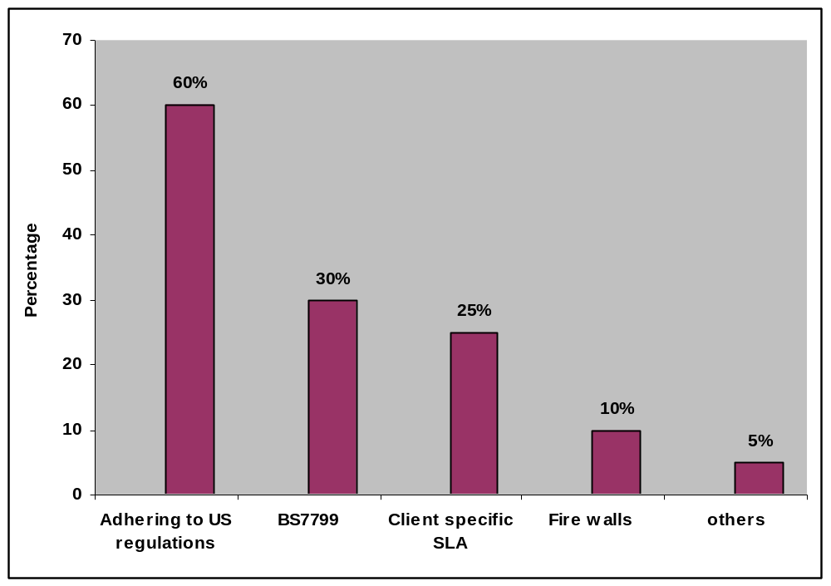
Source: Survey Findings
Note: (1) Total number of respondents-112: Independent BPOs-95, Captive BPOs-17
(2)Percentages add up to more than 100 because some companies have put in place more than one data protection measure.

Some US clients are asking Indian call centres to provide details of their employees and their prior employment records. This is often difficult to provide because the sector has a high attrition rate.

ITES/BPO companies have to often send people to the US to get business. Managers and technical people are sent to understand client requirements and familiarize with the work processes. Staff is also sent on-site for training. Most people are sent on B1 (business visitor) visa. Some are sent on L1 (intra-corporate transferees) or H1B visas but the requirement of these two visas in this sector is much less than in the case of the software sector. During the survey, it was pointed out that visa-related barriers affect trade in this sector. As shown in Table 4.1.1, delays in visa processing is the most common barrier faced by Indian BPO companies. It was pointed out that the average waiting period for getting a B1 visa interview is four weeks, but sometimes it stretches up to two months. Sometimes visas get rejected without valid reasons. First time travelers to the US who have to prove their credentials largely face this problem. Smaller companies have more chances of visa rejections than large companies. In the case of B1 visa, as per the rule, the employee has to be employed for a minimum period of three months before the visa can be applied for. This is a barrier for companies who want to send new employees to the US for training. Individuals traveling on B1 visas find it very difficult to extend the period of stay beyond six months. Survey participants felt that the application process is lengthy and cumbersome with requirement of multiple documentations. Visa problems are more acute for smaller companies than bigger or medium-sized companies. Independent BPOs pointed out that the delay in visa processing affects their on-time delivery of projects. Even the US captive BPOs pointed out that delay in obtaining visas hamper their business plans. They agreed that the visa regime needs to be more transparent.

Table 4.1.1: Visa-related Problems in the US
Visa Related Barriers | Percentage
Delay in visa processing | 50
Frequency of application rejected | 38
Problems in application process | 32
Restriction on period of stay | 8
No problems | 6

Source: Survey findings
Notes: (1) Total number of respondents- 109 (No Response-3): Independent BPOs- 93,
Captive BPOs- 16.
(2) The percentages add up to more than 100 because some companies face more than one visa problem.

Some of the barriers faced by the Indian ITES service providers are related to domestic regulation and government procurement. For instance, some US state licensing authorities give preference to specific professional degrees from certain countries. There are no clear guidelines on the procedure used for granting recognition from different countries. Non-recognition of qualification in certain professions such as accountancy, legal and health restricts the ability of companies to provide such services on the Internet. Residency and nationality requirements for certain professions such as legal and accountancy services also make it difficult to deliver these services through Mode 1.

India does not have a Totalization Agreement with the US. Due to this, Indian companies which send their employees to the US have to pay social security taxes in both countries. Unlike software services where this is a major trade barrier, only a few companies in the ITES/BPO sector listed this as a trade barrier in the US market. This is mainly because most employees in the ITES/BPO sector travel on B1 visas, which does not require social security payments. Employees traveling on H1B or L1 visas have to pay social security taxes.

Barriers faced by the US companies in India
The barriers faced by both the US captive and third party BPOs are related to poor infrastructure and manpower (see Figure 4.2.1 for details). Even Indian BPOs face these problems. These are largely domestic reform issues and most of them cannot be raised in an FTA negotiation.

Figure 4.2.1: Problems Faced by the US Companies in India
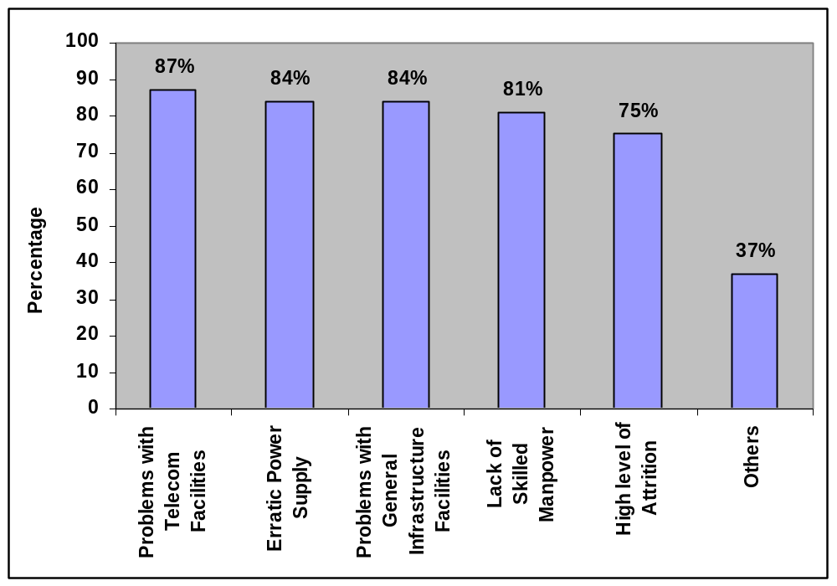
Source: Survey Findings
Notes: (1) Total number of respondents-38: Independent US BPOs- 31, Captive BPOs-17
(2) Percentages add up to more than 100 because some companies face more than one problem.

Growth of the ITES/BPO sector is highly dependent on the development of supporting infrastructure such as well-developed telecommunication facilities and uninterrupted power supply. Almost all the respondents expressed their dissatisfaction with the quality of these services. Although the telecommunication infrastructure in India is developing rapidly, the lead-time for commissioning of telecommunication services is still long – some companies claimed that it takes almost three months to get connectivity. Internet connectivity is slow and costs are quite high. As the BPO industry is developing very fast, the existing bandwidth capacity is not able to support the rising demand, leading to congestion. Moreover, even on high-speed broadband connections, consistency is not guaranteed. In India, none of the cities surveyed have a reliable 24 × 7 power supply. STPIs should provide uninterrupted power supply, but companies claim that there are power failures. To overcome this problem, most companies have invested in their own power back-ups (Uninterrupted Power Supply-[UPS], generators, etc.) which increase their operational costs.

Companies also complained about the lack of general infrastructure facilities such as roads, airports and mass transportation facilities. These facilities are necessary to make physical accessibility convenient. In cities such as Bangalore, companies were very vocal about the crumbling infrastructure. Traffic jams are frequent problems for employees who have to do shift duties. Since quality mass transportation is almost non-existing, most BPO companies have their own transportation system. The rise in fuel costs add to their operating costs. The cost of real estate is rising at a fast pace in places such as NCR. During the survey, almost 60 per cent of the respondents pointed out that poor infrastructure alone makes India less competitive compared to countries such as China.

Although India has a comparative advantage in the supply of skilled manpower, almost 81 per cent of the companies surveyed pointed out that they do not get employees with the required skills. Even for low-end operations, such as call centres, it is difficult to get people who have the right English communication skills. Some horizontal skills such as payroll, customer care, and documents management are in short supply. The problem gets compounded as the company moves up the value chain. There is shortage of expertise in verticals such as finance, insurance, real estate, healthcare and logistics. Training institutes have started offering courses specific to the needs of BPO industry, but they fall short of expectations. These institutes largely offer BPO industry-specific courses in accent neutralization, customer handling, team spirit and leadership, but not many offer domain-specific training (such as handling finance and insurance processes). To counter this problem, majority of the companies offer their own training.

All the companies surveyed pointed out that the high attrition rate is one of the biggest challenges facing the BPO companies. They incur significant amount of expenses in hiring people and training them and sometimes even before such costs are recovered the employee leaves the organization. Additional costs due to attrition ranged from 10 to 40 per cent. One of the key reasons for high attrition rate is lack of growth opportunities in the BPO industry. Respondents pointed out that only around 5 out of 150 BPO employees’ progress to the team lead positions. This creates frustration. Salary increase through job-hopping, poaching by headhunters, monotonous job and odd shift timings are some other reasons for the high attrition rate. Companies are providing various incentives such as higher salaries and employee-friendly work environment to retain people.

The survey found that rising salaries are adding to the cost of the companies. The Annual Salary Survey Report, 2005 by Hewitt Associates, a global human resources consulting firm, found that in 2005, India registered the highest average salary increase (13.9 per cent) in the Asia-Pacific region. Amongst all industries, IT-enabled industry had the highest salary hike (17.9 per cent). During the survey, 93 per cent of the independent BPOs agreed that there has been an increase in salaries in the past three years. They expressed their concern that this may lead to a decrease in profit margins. Captive BPOs were also concerned about the rising labour cost. A major advantage of India vis-à-vis other countries is low labour cost. If these costs continue to escalate, it may affect India’s global competitiveness. Some companies have already increased their billing rates to cover the extra cost due to increase in salaries.

Other barriers raised during the survey include high cost of capital, weak data protection laws, high rate of taxes and multiple taxes.

Indo-US FTA Negotiations
The analysis in the previous sections shows that the US is a major export market for Indian ITES/BPO services providers and the US companies have gained by outsourcing services to India. Hence, the two countries have trade complementarities in this sector which can be further enhanced through the proposed FTA.

The discussion in Section 4.1 shows that Indian companies face various barriers in the US market. With the suspension of the Doha Round of talks it has become more important than ever before to bilaterally negotiate to remove/reduce these barriers. Growth in Indo-US trade in ITES/BPO services would depend on India’s ability to negotiate the removal of existing barriers and pre-empt trade barriers that may arise in future.

One of the major barriers faced by Indian companies in the US is the restriction on temporary entry of professionals. As mentioned earlier, employees in the ITES/BPO sector are generally sent on B1 Visa. There are delays in the application process and sometimes visas get rejected without valid reasons. In its FTAs, the US has relaxed the visa regimes for its trading partners across different visa categories including B1. During the FTA negotiations, India should push for the removal of work permit/visa-related barriers. More specifically, India should ask for reduction in application time, removal of condition of prior approvals, relaxation of the requirement of multiple documentation and extension of period of stay, especially for business visitors and intra-corporate transferees. India should also push for removal of labour certification tests and licensing requirements. In its other FTAs, the US reserved certain visas for its trading partners. Since there is a very high demand for H1B visas in India, instead of asking for such reservations, India should push for making the entry norms similar to the H1B1 visas for certain categories of professionals.

India should bilaterally push for developing disciplines on domestic regulation. In particular, it should push for the removal of licensing, residency, and nationality-related barriers for professionals. The FTA can facilitate cooperation among professional bodies of the two countries to work together for degree equivalence. Professional bodies from India and the US can sign MRAs in certain services such as accountancy and architecture. This would ease recognition-related barriers to cross-border trade. It is important to note that although an FTA is not a pre-requisite for a MRA since MRAs are independently entered into by professional bodies without government intervention; the Indian experience shows that post-CECA professional bodies of the two countries are seriously working towards signing the MRA.

In the past, India expressed reservation in signing the GPA in the WTO. Also, government procurement has not been included in the Indo-Singapore CECA. It is likely that during the FTA negotiations, the US would ask India to negotiate on government procurement. Since many of the anti-outsourcing bills prohibits state contract work to be performed overseas or require such work to be done by US citizens, India can raise them during negotiations on government procurement. However, India should be careful in addressing the government procurement issue bilaterally since it would be difficult for India to offer liberal commitments in government procurement for certain services such as financial services. Moreover, for government procurement in services, there may be gains for the ITES sector but the country may need to compromise in other sectors such as social sectors, energy, water and finance which may be difficult for India to offer. For quasi-federal government, as in the case of the US and India, state level procurement is a sensitive issue. As shown in Appendix B, many of the US states are coming up with legislation which states that the state would not be a party to the international trade agreements on procurement.

During the negotiations, the US is likely to push for a negative listing of service sectors. India has followed a positive list approach in its CECA with Singapore. However, positive listing does not ensure wide sectoral coverage which is required to have significant commitments in Modes 1 and 2 due to their horizontal nature. India should consider following the negative list approach and accordingly draw up a list of excluded sectors, which would include sensitive service sectors. Since ITES is a technology driven sector any commitments need to take into account technological developments in the future.

The US companies have already pointed out that India has a weak data protection regime and this issue has been raised in some anti-outsourcing bills. It is likely that during the bilateral negotiations the US would raise this issue. For enhancing trade in ITES/BPO services it is important for India to strengthen its data protection regime and implement international standards. Under the FTA, India can enter into a partnership agreement with the US on cyber security which would include data privacy, IPR, among others. The two countries should enhance cooperation in IPR implementation and enforcement.

The FTA should enhance collaboration between industry associations such as Information Technology Association of America (ITAA) and NASSCOM. ITAA and NASSCOM can play a vital role in promoting trade in ITES sector by raising awareness of the benefits of outsourcing in the US, getting US clients in touch with Indian service providers and advocating right policies to the respective governments. The FTA should market the key strength of Indian companies in the US by increasing government-to-government and people-to-people contact through seminars, road shows, conferences, etc. As Indian companies are trying to move up the value chain, the FTA should enhance cooperation in areas such as R&D services. India and the US should also collaborate in setting up institutes in India which would offer training in skills specific to this sector.

Overall, both Indian and the US companies felt that the proposed Indo-US FTA would have a positive impact on trade in this sector and ITES/BPO sector should be treated as a priority sector in the FTA negotiations.

Reforms
This section will discuss the reform measures that are needed to support the growth of ITES/BPO services, enhance its efficiency and global competitiveness and enable the country to gain from bilateral liberalization under the proposed FTA.

The supporting infrastructure should be upgraded. Although there has been significant growth in the telecommunication sector, there is an urgent need to lower the broadband cost further and increase connectivity, reliability, and performance standards. Private players should be encouraged to invest in setting up broadband network through proper incentives such as single window clearance. High-speed telephone connectivity should not just be limited to bigger cities. It should also spread to smaller cities such as Chandigarh where BPO sector is expanding.

In India, power consumption has been increasing steadily and the installed capacity is unable to meet the rising demands. There is need for restructuring the Transmission and Distribution (T&D) sector within the power sector to prune losses. In this regard, the central government has been urging states to restructure the State Electricity Boards (SEBs) into viable, commercial entities and set up power sector regulators. However, reforms in the power sector is slow as it is a ‘state’ subject and it is upto the state governments to initiate reforms. In this regard, Andhra Pradesh is one of the leading states to initiate power sector reforms. IT/ITES companies are exempted from power cuts in this state. Other states should follow this policy and come up with committed power sector reforms.

There is an urgent need to invest in basic infrastructure such as roads and airports in cities such as Bangalore and the NCR. The government has recently announced the privatization and upgradation of Delhi and Mumbai airports. Airports in cities such as Bangalore also need to be modernized and their capacity should increase. As smaller cities such as Chandigarh and Pune are upcoming BPO destinations, airports in these cities should be upgraded. With a number of private airlines coming into operation, flight connectivity has increased. The existing airports do not have the capacity to handle the increasing number of flights. There is urgent need for construction of new airports. For within city travel, there is need for alternative transport system such as the underground railways. This would help to ease congestion in cities such as Bangalore. Since provision of basic infrastructure within the cities is largely in the hands of state governments and local bodies, there is greater need to raise awareness among state governments and local bodies and enhance centre-state coordination in upgrading infrastructure.

During the survey, several companies have raised the issue of data protection. As mentioned earlier, India does not have a specific data protection law. The Information Technology (IT) Act 2000 covers only unauthorized access and data theft from computers and networks, with a maximum penalty of about US$ 220,000, but does not have specific provision relating to privacy of data. In the past, there have been a few cases of misuse of sensitive client data by BPO employees. To review the Act, an Expert Committee on Amendments to IT Act, 2000 was formed in 2005. The committee proposed certain amendments, which is now awaiting Cabinet approval. The new clauses would enable the Act to conform to the so-called adequacy norms of the European Union’s Data Protection Directives and the Safe Harbor privacy principles of the US. The IT Act 2000 should be amended at the earliest in line with the recommendations of the Expert Committee. NASSCOM has also been proactively working on strengthening data protection regime in India.

Another issue that was raised during the survey was inadequacy of skilled manpower. As has been already discussed, courses offered by training institutes fall short of expectations. Therefore, the government should work closely with the industry to identify skills that are in short supply and take measures to set up training facilities accordingly. There is an urgent need to set up more specialized institutes with curriculum specially designed for this industry. Schools and colleges should be encouraged to set up focused supplementary courses to sharpen the communication skills and to prepare students for the BPO sector. Already the private sector is working closely with the government and other organizations for providing training. For instance, IBM is collaborating with selected universities to train over 75,000 students in the next few years. Microsoft is working with NASSCOM to initiate a collaborative effort in which all IT firms can come together and launch a concerted initiative for creating the requisite IT talent. In March 2006, NASSCOM announced the launch of the NASSCOM Assessment of Competence (NAC) program at Sikkim Manipal University (SMU). An NAC centre has been established at the university campus that will periodically assess competency, skill and capability of students. This is a good step that would help to build the necessary workforce for the requirement of the IT-BPO industry.

The government should focus on bringing the professional educational courses up to international standards. Without domestic standardization of the educational system it would be difficult for India to sign MRAs with the US.

Governments of competing countries such as China, Philippines and Malaysia are proactively promoting their ITES/BPO sector through tax holidays and other incentives. Although the Indian industry is happy with the existing incentives, they pointed out that the government should not end the tax holiday after 10 years if competing countries are offering tax incentives to this industry. They also pointed out that given the nature of the sector, labour flexibility is essential for its performance. Some political parties have recently raised the issue of labour unions and restrictions on hire and fire. Any such measures can adversely affect this industry. The government should proactively publicize and market this sector in all its international engagements.

Conclusion
With increased globalization and development of information technology developed countries such as the US are outsourcing a large component of back-office and front office services to developing countries such as India. This paper discusses the trade between India and the US in the ITES/BPO sector in the context of a possible FTA. The study found that the two countries have strong trade complementarities in this sector and majority of India’s trade in ITES/BPO services is with the US. The study also pointed out that both the US and India have gained through outsourcing. Outsourcing enabled the US companies to reduce cost and at the same time maintain the same or higher levels of productivity and efficiency. In India, relocation has led to employment creation, economic development, increase in wages and growth of ancillary industries. Based on the survey, the study found that ITES/BPO would continue to be a key business decision for the US companies and bilateral trade in this sector would increase. Indian companies are moving up the value chain to provide specialized services to the US clients.

The study discussed the difficulties in multilaterally negotiating greater market access in this sector. With the suspension of the Doha Round, multilateral negotiations have slowed down and countries have renewed their focus on bilateral agreements. While multilateral negotiation is the best route to gain greater market access in services, in certain areas, the US-FTAs have achieved a higher level of liberalization than under the GATS. The US has also shown more willingness to relax the visa/work-permit related barriers in its bilateral agreements than in the WTO. By following a negative list approach, the US-FTAs have a more comprehensive sectoral coverage than under the GATS.

The study found that Indian companies are facing several barriers in the US market such as anti-outsourcing bills, barriers to temporary movement of people in the US, concerns about data protection regime in India and domestic regulation related barriers. The FTA can help to enhance trade in this sector if these barriers can be addressed during the bilateral negotiations. It suggested various negotiating strategies for India which would enhance market access for Indian professionals in the US. It pointed out that given the cross-sector nature of these services, on its part, India should consider following a negative list approach for making commitments. India’s negotiating strategies should not only focus on removing existing barriers but India needs to pre-empt trade barriers that may arise in the future. India and the US should collaborate to strengthen India’s data protection regime and implement international standards. The proposed FTA should enhance cooperation and collaboration among industry associations of the two countries and market the key strength of Indian companies in the US. Collaboration in training and skill development would be beneficial for India.

The study listed certain domestic reforms which, if implemented, will enhance productivity, efficiency and global competitiveness of this sector and enable the country to gain from the proposed FTA.

Bibliography

Amiti, M and S J Wei (2004), ‘Fear of Service Outsourcing: Is it Justified?’, Working Paper 1080, October 2004, National Bureau of Economic Research (NBER), Cambridge.

AT Kearney (2004), Offshore Location Attractive Index, Making Offshore Decisions, 2004, AT Kearney, Washington DC, pp. 6-15.

Berkey, J O (2001), ‘A Framework Agreement for Electronic Commerce Regulation under the GATS’, January, 2002, Institute of International Finance, Washington DC.

Borga, M and M Mann (2004), ‘U.S. International Services: Cross-Border Trade in 2003 and Sales through Affiliates in 2002’, October, 2004, BEA, US Department of Commerce.

‘BPO gains corporate acceptance: Survey’, 23rd April, 2004. http://www.rediff.com/money/2004/apr/23bpo2.htm.

Chanda, R (2003), ‘Linkages between Mode 4 and other GATS Modes of Supply’, OECD — WORLD BANK — IOM Seminar on Trade and Migration, Geneva, 12-14 November, 2004.

Comprehensive Economic Cooperation Agreement (CECA) - India and Singapore.
http://commerce.nic.in/ceca/toc.htm

Department of Information Technology (2005), Proposed Amendment to Information Technology Act 2000, Summary, Report of the Expert Committee, August 2005, Department of Information Technology, India. www.mit.gov.in

Drezner, D (2004), ‘The Outsourcing Bogeyman’, Foreign Affairs, May/June, 2004, US Council on Foreign Relations.

Final Text of Free Trade Agreement -USA and Australia.
http://www.ustr.gov/assets/Trade_Agreements/Bilateral/Australia_FTA/Final_Text/asset_upload_file322_5157.pdf

Final Text of Free Trade Agreement -USA and Chile.
http://www.ustr.gov/assets/Trade_Agreements/Bilateral/Chile_FTA/Final_Text/asset_up load_file759_4007.pdf

Final Text of Free Trade Agreement -USA and Singapore.
http://www.ustr.gov/assets/Trade_Agreements/Bilateral/Singapore_FTA/Final_Text/asset_upload_file708_4036.pdf

Ganguly, D (2005), ‘Barriers to Movement of Natural Persons: A Study of Federal, State and Sector-Specific Restrictions to Mode 4 in the United States of America’, Working Paper 169, September, 2005, ICRIER, New Delhi.

Gartner Press Release (2003), ‘Gartner Survey Shows Business Process Outsourcing is No Longer Just for Large Corporations: Survey Shows BPO Vendors Expanding Offerings to Smaller Companies’, 3rd April, 2003, http://www.gartner.com/5_about/press_releases/pr3apr2003a.jsp.

IDC (2002), Worldwide Business Process Outsourcing Forecast and Analysis, 2002-2006, International Data Corporation (IDC), Massachusetts, USA, pp.28-30.

‘Indians set to get highest pay hikes’, 23rd November, 2005, http://www.rediff.com/money/2005/nov/23salary.htm.

‘IT majors should focus on creating a talent pool to retain BPO chances: MS India chief’, 6th April, 2005, Financial Express. http://www.financialexpress.com/fe_full_story.php?content_id=87230.

Lawrence, R Z and R Chadha (2004), ‘Should a U.S.-India Free Trade Agreement Be Part of India’s Trade Strategy?’, in S Berry, B Bosworth, and A Panagariya (eds), The India Policy Forum 2004 (Vol. I). Brookings Institution, pp. 69-134.

Mattoo, A and S Wunsch-Vincent (2004), ‘Pre-Empting Protectionism in Services: The GATS and Outsourcing’, Journal of International Economic Law 2004 (Vol 7, Issue 4), Oxford University Press, pp. 765-800.

NASSCOM (2003), Strategic Review, 2003, IT Industry in India, NASSCOM, New Delhi, pp. 56-71.

NASSCOM (2004), Strategic Review 2004, IT Industry in India, NASSCOM, New Delhi, pp. 57-77.

NASSCOM (2005), Strategic Review 2005, IT Industry in India, NASSCOM, New Delhi, pp. 78-101.

NASSCOM (2006), Strategic Review 2006, IT Industry in India, NASSCOM, New Delhi, pp. 72-95.

NFAP Policy Brief (April 2005), ‘Proposed Restrictions on Global Sourcing Continue at High Level in 2005’, National Foundation for American Policy (NFAP), Virgin Atlantic, USA.

Panagariya, A (2004), ‘Miracles and Debacles: In Defence of Trade Openness’, The World Economy, August 2004, Vol. 27(8), Blackwell Publishing, pp. 1149-1171.

‘Proposed Amendments to Indian Information Technology Law provide for Data Protection’, 30 August, 2005, http://www.commliba.org/modules.php?name =News&file= article&sid=129.

Roy, J and P Banerjee (2004), ‘US-India Free Trade Agreement in Services: An Analysis of issues for discussion’, Approach Paper, CII, India.

‘New Jersey decides to move call centre from Mumbai to Camden’, 23rd April, 2003, http://www.rediff.com/money/2003/apr/23bpo.htm

Singh, D (2002), ‘Electronic Commerce: Issues of Policy and Strategies for India’, Working Paper 86, September, 2002, ICRIER, New Delhi.

‘The United States E-3 Treaty Professional Visa for Australian Nationals’, Department of Foreign Affairs and Trade, Australian Government.

United Press International (2004), ‘Anti-outsource laws violating trade rules’, 19th April, 2004, http://www.upi.com/inc/view.php?StoryID=20040419-100017-5755r.

US India CEO Forum (2006), US-India Strategic Economic Partnership, March 2006.
http://planningcommission.nic.in/reports/genrep/USIndia.pdf#search=%22us%20india%20ceo%20forum%22.

WTO (1994), Agreement on Government Procurement.
http://www.wto.org/english/tratop_e/gproc_e/gp_gpa_e.htm

WTO (1991), Services Sectoral Classification List, 10 July 1991, MTN.GNS/W/120.

WTO (2005a), Doha Work Programme Ministerial Declaration, 22 December 2005, WT/MIN (05)/DEC, Hong Kong.

WTO (2005b), US Revised Offer in Services, 31 May 2005, TN/S/O/USA.

WTO (2005c), India Revised Offer in Services, 24 August 2005, TN/S/O/IND/Rev.1.

WTO (2004), Communication from Chile, India and Mexico, ‘Joint Statement on Liberalization of Mode 1 under GATS negotiations’, 28 June 2004, JOB (04)/87.

Appendix A: Sample Questionnaires
US CAPTIVE BPOs

COMPANY PROFILE

1. Name and Address of the company

2. Which industry verticals do you operate in?

Industry Vertical | ( √ ) Tick in the relevant row
Financial Services
Automotive
Telecommunication
Retailing
Computer Equipment
Any Other (Specify)

ENTRY:

3. Which year did you set up BPO operations in India?

4. How is company linked with the parent company? (For example, joint venture, wholly-owned subsidiaries)

5. What is your area of operation – by service line?

Service | ( √ ) Tick the appropriate one
Customer Care
Finance
HR Services
Payment Services
Administration
Content Development
Any Other (Specify)

6. Which of the following factors determined the choice of India as an outsourcing destination?

Factors | ( √ ) Tick the appropriate one
Large pool of English-speaking people
Low cost labour
Educated workforce
Higher productivity and efficiency
Government incentives (such as setting up of software technology parks)
Unique time zone which permits 24 x 7 service
Global reputation in software
State-specific policy (Specify)
Others (Specify)

7. What are your future expansion plans?

8. Do you plan to become an independent BPO in the near future? Why?

9. What factors determined the choice of location in India?

10. Do you get benefits/supports from the Indian government (such as tax concessions, etc)? If yes, give details.

Central Government
State Government (Specify)

11. Have you set up similar operations in other countries? If yes, then in which other countries have you set up similar operations.

12. How would rate other countries vis-à-vis India?

Country | Advantages | Disadvantages

13. What percentage of the total turnover of your BPO operations is from India and how much is from other countries where you have operations?

14. Which of the following benefits do you get by offshoring to India? Give details:

Benefits | Details
Cost Reduction
Productivity Gains
Improved Quality of service
24 × 7 services
Others (Specify)

15. Which of the following problems do you face while operating in India? Give details.

Problems | Details
Lack of developed telecommunication infrastructure
Slow network connectivity
Insufficient bandwidth
High connectivity cost
Erratic power supply
Other infrastructure problems
Slow and cumbersome clearance process
Getting the employees of the right skills
Indian legal system
Problems relating to data protection, IPR
Problems relating to privacy, confidentiality of information
Others (specify)

DATA PROTECTION AND SECURITY:

16. What is your information security policy?

17. Do you face problems due to the absence of data protection law in India?

EMPLOYEES’ DETAILS:

18. What are the factors which determine the selection procedure of recruiting professionals in India?

19. What kind of skill levels are required for your operations?

20. Do you face any problems in getting staff with the required skills in India? If yes, then give details.

21. Are the Indian employees recruited on project/contract/permanent basis?

22. What factors play a role in determining the salary of the Indian staff?

23. Are the salaries of Indian professionals paid by you at par or higher than what are paid by local firms?

24. What kind of training do you provide to the employees?

25. Do you send your employees to the US for training?

26. Does staff attrition pose a problem? If yes, how much extra cost do you suffer due to it?

27. What steps have you taken or propose to take to avoid high rates of attrition?

28. Do you bring professionals to India from the US? If yes, on an average how many employees come to India from the US in a year? What are their usual job responsibilities?

29. Are the US employees deployed in India on temporary or permanent basis?

30. Do you have to pay social security for the US employees in both India and the US simultaneously? If yes, do you think you will gain if the two countries sign an agreement which will prevent double taxation?

VISA:

31. What type of visas do you usually apply for the US employees coming to India?

32. Do you face any of the following problems? If yes, give details.

Problems | Details
Problems in application process
Frequency of application rejected
Delay in Visa processing
Restriction on period of stay
Any other (Give details)

33. What support or reforms do you expect from the Indian Government?
34. Have you ever felt that you have lost business due to the anti-BPO sentiments and laws in the US? If yes, give details.

35. Do you think that anti-BPO sentiments may affect your business in future? Give details.

36. What would be the major challenges for the Indian BPO sector in future?

37. What are the growth prospects of this sector?

38. Do you think that the BPO sector would gain from an Indo-US Free Trade Agreement in services? Give reasons.

39. In your opinion, what more needs to be done to improve the competitiveness of this sector in the light of an Indo-US Free Trade Agreement?
Third Party/Independent BPOs

COMPANY PROFILE:

1. Name and Address of the company

2. What is your area of operation – by service lines?

 | Area of Current Operation | Area in which you would like to operate in future
Customer Care
Finance
HR Services
Payment Services
Administration
Content Development
Any Other (Specify)

3. Which industry verticals do you operate in?

Industry Vertical | ( √ ) Tick in the relevant row
Financial Services
Automotive
Telecommunication
Retailing
Computer Equipment
Any Other (Specify)

4. Which year was the company formed?

5. Why did you enter into the BPO sector?

6. What is your source of capital?

7. Are you associated with a software company?

8. If associated with the software company - were you associated with it since the start of the business or did you have a merger/strategic alliance? If merger/alliance, why did you go in for the merger?

9. What kind of information security practices do you follow (such as BS7799 certification)? Give details.

10. What kind of pricing model have you adopted?

Type of pricing models | ( √ ) Tick in the relevant row
Per unit time variable (per seat, per hour)
Per seat ( or employee) per month
Incident or activity-based
Gain-share based
Total cost of ownership-based
Others (Specify)

11. What are your plans in terms of moving up the value chains?

 | The Value Phases | Reasons
By area of operation
By industry verticals

12. What factors determined the choice of location in India?

13. What are the strengths and weaknesses of India vis-à-vis other countries?

Strengths of India
Weaknesses of India

14. Who are your major competitors? What are their strengths?

Indian Companies
Foreign Companies

15. How do you generally get your business?

16. Do Indians employed in the US firms play an important role in getting business for you?

17. Do you exclusively serve the US companies? If not, list all other major countries where you have clients.

18. Who are your major US clients? And how many of these are Fortune 500 companies?

US Clients | No. of Fortune 500 companies

19. Why are the US companies offshoring work to India? (Give 5 main reasons)

20. Your company’s turnover:

Year | Total turnover from BPO operations | Turnover from servicing the US clients.

BENEFITS

21. Do you get any benefit/support from the Indian Government (such as tax concessions)? If yes, give details.

22. Do you need any more incentives/support from the Indian Government?

23. What do you think will be the future drivers of this industry?

24. What benefits does India derive due to offshoring?

Benefits | ( √ ) Tick the appropriate one
Employment generation
Diversification of employment opportunities
Higher wage rate compared to local jobs requiring similar qualification
Greater investment
Growth of ancillary services (transportation, security, etc.)
Upgradation of skills and technology
Others (specify)

EMPLOYEES’ DETAILS

25. How many employees are currently employed?

26. How do you select your employees? (Give details of the selection procedures)

27. Do your clients play a role in the selection procedure of the employees? If yes, give details.

28. What kinds of skill levels are required for your operations?

29. What kind of training do you provide to your employees?

30. Do you send your employees to the US for training?

31. Do you face high attrition rates? What are the main reasons for the high attrition rate in this sector?

32. Does staff attrition pose a problem? If yes, how much extra cost do you suffer due to it?

33. What steps have your taken or propose to take to prevent high rates of attrition?

34. Have the salaries in the BPO sector increased during the past few years? If yes, how has this affected your business?

VISA-RELATED QUESTIONS

35. Do you send employees to the US to get business?

36. What are the visa categories which are usually applied for when you send employees either for training or for getting business?

37. How long is the visa process?

38. Do you face the following problems? If yes, give details.

Problems | Details
Problems in application process
Frequency of application rejected
Delay in visa processing
Restriction on period of stay
Others (Specify)

DATA PROTECTION AND SECURITY

39. What Kind of information security policy would you like to have?

40. Do you face problems due to the absence of data protection law in India?

OTHER PROBLEMS

41. Which of the following problems/barriers do you face in India?

Problems/Barriers | Details
Lack of developed telecommunication infrastructure
Slow network connectivity
Insufficient bandwidth
High connectivity cost
Erratic power supply
Other infrastructure problems (Specify)
Slow and cumbersome clearance process
Multiple licensing
Tax-related problems
Location-related problems
Getting the employees of the right skills
Others (specify)

42. Have you ever lost business opportunities in the US due to anti-BPO sentiments and laws? If yes, give details.

43. Do you think that anti-BPO sentiments may affect your business in future? Give details.

44. What would be the major challenges for the Indian BPO sector in future?

45. What are the growth prospects of this sector? Which areas/industry verticals/service lines would witness rapid growth?

46. Do you think that the ITES/BPO sector would gain if India enters into an FTA with the US? Why?

47. What more needs to be done to improve the competitiveness of this sector in the light of an Indo-US Free Trade Agreement?

Appendix B: List of US State-level Legislations against Outsourcing
State laws passed on offshore outsourcing in 2004 and 2005

States | Summary of Legislations
Alabama | Senate Joint Resolution 63. A resolution that encourages state and local entities to use Alabama-based professional services. Does not restrict or place mandates on procurement decisions. Became public law 2004-234.
Colorado | House Bill No. 1373. Agencies can contract for personal services performed outside the United States if it is clearly demonstrated that there will be no reduction in the quality of services offered and contracts contain confidentiality and right to privacy safeguards. Signed by Governor June 4, 2004.  HB 1307. Provides an in-state preference for agricultural products and prohibits Governor from binding state on future trade agreements. Signed by Governor on June 7, 2005.
Indiana | House Bill No. 1080. Provides price preferences between 1 and 5 per cent for Indiana companies in the awarding of state contracts. Signed by Governor 3/17/04.
North Carolina | House Bill No. 1414 Preference for North Carolina or U.S. products and services within bounds of federal law “provided, however, that in giving such preference no sacrifice or loss in price or quality shall be permitted.” Signed by Governor July 21, 2004.  HB 800. Requires a vendor submitting a bid to disclose “where services will be performed under the contract,” including performance outside the United States. Signed by Governor July 7, 2005.
Tennessee | Senate Bill No. 2344. Requires the commissioner of finance and administration to authorize, through regulation, “a preference in the evaluation of proposals for state contracts requiring the performance of data entry and/or call center services for vendors for whom such services will be solely provided by citizens of the United States who reside within the United States.” Signed by Governor 5/10/04.
California | AB 1741. Prohibits voter information from being sent outside the United States. Signed by Governor on July 25, 2005.
Illinois | S 1723. Provides a preference of items manufactured in the United States for procurement purposes. Signed by Governor on August 10, 2005.
Maryland | HB 514. Prohibits Governor from binding state on future trade agreements. Legislature voted to override Governor’s veto of bill on April 11, 2005.
New Jersey | S 494. Prohibits state contract work from being performed outside the United States. Signed by Governor on May 5, 2005. This law represents the most restrictive anti-outsourcing legislation in the nation.
North Dakota | H 1091. Provides an in-state preference on equal bids on state contracts. Signed by Governor on March 30, 2005.
Maine | LD 47. It requires “the necessity of collecting information on the State’s contracting and outsourcing practices.” Signed by Governor May 12, 2005.
New York | AR 184. The resolution creates the "Outsourcing and Offshoring Commission" to, among other things, “study ways to reduce outsourcing and off-shoring in the State.” Resolution adopted July 6, 2005.
Washington | CR 8407. It establishes a far-reaching joint task force for the study of offshore outsourcing. Adopted on April 24, 2005.
List of States who have proposed Legislation Restricting Outsourcing: 2005

State | Nature of the Restrictions
Alabama | Health care data transfer restrictions
Arizona | State contract ban on overseas work; Call center restrictions
California | Requires disclosure of location of work on state contracts; In-state preference
Colorado | State contract ban on overseas work; Health care data transfer restrictions
Connecticut | State contract ban; Call center, personal data and health care information restrictions; Development assistance restriction for outsourcing companies; In-state preference; 90-day notice for transferring 25 per cent of workforce
Florida | Call center and health care/data restrictions; Report on location of state work
Georgia | Call center restrictions on state contracts
Hawaii | State contract ban on overseas work; In-state hiring preference; Development assistance restriction for outsourcing companies
Idaho | State contract ban
Illinois | Health care data transfer restriction; Call center restrictions
Indiana | State contract ban on overseas work
Iowa | State contract ban; Call center restrictions
Kansas | Call center restrictions
Maine | State contract ban on overseas work
Maryland | State contract ban; Trade agreement restriction
Massachusetts | State contract ban
Michigan | In-state preference
Minnesota | State contract ban; Data transfer and call center restrictions; Reporting terminations
Mississippi | State contract ban on overseas work; Call center restrictions
Missouri | State contract ban on overseas work; Call center restrictions; In-state preference
Montana | State contract ban on overseas work
Nebraska | State contract ban on overseas work; Health care data transfer restrictions; In-state preference
Nevada | Data transfer restrictions
New Hampshire | State contract ban; Development assistance restriction for outsourcing Companies; In-state preference
New Jersey | State contract ban on overseas work; Call center restrictions
New Mexico | Data restrictions
New York | State contract ban; Development assistance restriction for outsourcing companies; Notification to workers of outsourcing
North  Carolina | Contractors must disclose where work on state contracts will be performed
North Dakota | State contract restriction; In-state preference
Ohio | State contract ban on overseas work; Outsourcing compensation fund for employees
Oklahoma | State contract ban
Oregon | State contract ban; Call center restrictions; Create Office of Trade Enforcement that will provide annual report and recommendations on offshore outsourcing; Trade agreement restrictions
Pennsylvania | No job transfers overseas without board approval; State contract ban; Taskforce established to investigate outsourcing
Rhode Island | State contract ban
South  Carolina | In-state preference
Texas | State contract ban on overseas work; Health care data transfer restrictions
Utah | In-state preference
Virginia | State contract ban
Washington | State contract ban
West Virginia | Call center restrictions; State contract and development assistance restrictions for outsourcing companies
Wisconsin | State contract ban
Source: Compiled by authors from National Foundation for American Policy website, http://www.nfap.net/researchactivities/globalsourcing

Notes: (1) As of October 2005, there were 127 bills in 40 states in that year to restrict outsourcing.
(2) A ‘state contract ban’ refers to a bill that would prohibit work on state contracts to be performed overseas or by individuals not authorized to work in the U.S. Call center restrictions refer to bills that mandate operators identify their location in some manner. Health care and data transfer restrictions refer to bills that would either ban or require an ‘opt-in’ for data to be processed outside of the US. Trade agreement restriction refers to the mandate that the state would not be a party to the international trade agreements on procurement.

Appendix C : GATS Framework

A unique feature of GATS is the classification of the services trade under four different modes:

Cross-border Supply or Mode 1 refers to the delivery of services across countries such as the cross-country movement of passengers and freight, electronic delivery of information and data, etc.

Consumption Abroad or Mode 2 refers to the physical movement of the consumer of the service to the location where the service is provided and consumed.

Commercial Presence or Mode 3 refers to the establishment of foreign affiliates and subsidiaries of foreign service companies, joint ventures, partnerships, representative offices and branches. It is analogous to foreign direct investment in services.

Presence of Natural Persons or Mode 4 refers to natural persons who are themselves service suppliers, as well as natural persons who are employees of service suppliers temporarily present in the other member’s market to provide services.

In Modes 1 and 2, service supplier is not present within the territory of the member, while in Modes 3 and 4, service supplier is present within the territory of the member.

The GATS contains two sorts of provisions. The first are general obligations, some of which apply to all service sectors (for example, MFN and Transparency) and some only to scheduled specific commitments (for example, Article XI: Payments and Transfers). The second are specific commitments, which are negotiated undertaking particular to each GATS signatory.

Under the Most Favoured Nation (MFN) Treatment (Article II) a member is obliged to provide to another member treatment which is no less favourable than that it provides to any other country, whether a member or not (i.e., if a WTO member country offers a certain privilege to any other country, whether it be a member or not, it has to extend the same treatment to all WTO member countries). However, GATS allowed member countries to undertake exemptions to this clause, in their initial commitments in the Uruguay Round, subject to review.

Transparency (Article III): This clause requires each member country to publish all measures of general applications which pertain to or affect the operation of the Agreement. Countries are also required to publish international agreements pertaining to or affecting trade in services. Or in other words, the Council of Trade in Services will have to be informed, at least annually, of the introduction of any new, or any changes to existing laws, regulations and administrative guidelines. WTO member countries can make request regarding specific information, which the concerned country will have to provide promptly. Article III requires member countries to establish enquiry points to provide specific information to other members.

The GATS aims to progressively liberalize services trade under the four modes of service supply. For each mode, a country can impose two types of barriers: market access barriers and/or national treatment barriers. A country is said to have imposed a market access barrier if it does not allow (or partially allow with some restrictions) foreign services or service providers to enter and operate in its market. A national treatment barrier exists when foreign services or service providers are allowed to enter the market but are treated less favourably than domestic service providers. During the successive rounds of negotiations, member countries negotiate and undertake commitments to liberalize market access and/or national treatment in specific sectors in what is known as sectoral schedule of commitments and across all or several sectors in the horizontal schedule of commitments. Both the sectoral and horizontal schedules have to be read together to understand the extent and nature of commitments undertaken in a particular sector. Thus, market access and national treatment are negotiated obligations. It is possible for countries not to grant full market access and deny national treatment by putting limitations and conditions on market access and conditions and qualifications on national treatment in particular sectors/sub-sectors. This is done by recording such limitations and qualifications in the commitment schedules under market access and national treatment columns. In its schedule a country is said to have made a ‘full’ commitment in a particular mode of supply of service if there are no restrictions on market access or national treatment. A country is said to have made a ‘partial’ commitment if the commitment is subject to some restrictions on market access and/or national treatment. If a country does not make any commitment to liberalize a particular sector or mode of supply and retains the right to impose restrictions in the future, then it is said to have kept the sector/mode ‘unbound’. It is expected that successive rounds of negotiations will secure further liberalization by adding more sectors to a country’s schedule and removing limitations and qualifications, if any, in sectors/sub-sectors already in the schedule. This is done mode-wise for each sector/sub-sector. It is also possible for countries to make commitments which are outside the scope of market access and national treatment as defined in the GATS. These are called Additional Commitments (Article XVIII). This provides scope for making commitments in such regulatory areas as licensing, qualifications and standards applicable to services.

GATS covers all services except those supplied in the exercise of government authority. It follows a positive list approach which indicates that there is no a priori exclusion of any service sector and that countries are free to choose the service sectors/sub-sectors and modes within those sectors/sub-sectors for scheduling commitments.

Appendix D: Comparison between H1B Visa and H1B1 Visa under the US-Singapore and the US-Chile FTAs

H1B VISA | H1B1 VISA
Procedural Requirements
A petition has to be filed with United States Citizenship and Immigration Services desiring H1B status.  The individual must possess relevant professional license for admission.  H1B specialty occupation workers are admitted for up to three years initially with maximum extensions up to six years.  Applicants for H1B visa do not have to demonstrate that they intend to return to their home country when their temporary job is over.  The H1B visa is currently subject to a labor market test. | There is no petition requirement. Individuals must apply directly to the Department of State for H1B1 visa. They have to submit a job offer letter, relevant credentials, H1B1 labor attestation and any other relevant documents.  There is no licensure requirement as pre-requisite for admission. But professionals admitted under H1B1 will have to comply with the applicable state and federal licensure requirements related to their respective professions.  H1B1 professionals are admitted for one year initially and they may extend their stay indefinite number of times, in one year increments. While extensions and renewals are allowed indefinitely, adjustment of status to another non-immigrant category or to legal permanent residency is not permitted.  All Singaporean and Chilean H1B1 professionals have to demonstrate that they intend to return to Singapore/Chile when their temporary job is over.  No labor market test is required under the H1B1 visa. This means that the US employer does not need to prove that no other American can take the job that the Singaporean/Chilean is applying for.
Numerical Limits
Annual numerical limits are set for the foreigners who can obtain H1B visa. Currently, the law limits the number of H1B visas to 65,000 per year. | Presently, the US has set 5,400 as the limit for professionals from Singapore who can obtain H1B1 visa. For Chilean professionals, the limit is 1,400 H1B1 visas. These numerical limits fall within and will be registered against the existing annual numerical limit for H1B visa. Only principals are counted against each country’s respective numerical limit. At the end of each fiscal year, unused H1B1 numbers will be returned to that year’s global numerical limit and will be made available to H1B aliens during the first 45 days of the new fiscal year.
Professional Categories
H1B visa allows for entry of professionals in the ‘specialty occupations’ subject to attainment of a US bachelor’s or higher degree from an accredited college or university. If the person holds a foreign degree, the degree must be determined to be the educational equivalent of a US bachelor’s degree. In some cases, a person may obtain an educational equivalence through a combination of education, specialized training or a progressively responsible work experience. | The statutory and regulatory definition of ‘specialty occupation’ is the same for both H1B visa and H1B1 visa. However, both the FTAs allow for exception to degree requirements with respect to certain professions as mentioned below:  For Singaporeans- Disaster relief claims adjuster and Management consultants have been allowed exception to degree requirements. For these occupations, they require a combination of specialized training and three years experience in lieu of the standard degree requirement.  For Chileans- In addition to the two occupations mentioned in the US-Singapore FTA, there are two other occupations which have been given exception to the degree requirements: Agricultural managers and Physical Therapists.  Consular officers may accept specified documentary evidence of alternative credentials.
Source: Compiled by the Authors.

LATEST ICRIER'S WORKING PAPERS

NO. | TITLE | AUTHOR | YEAR
186 | ASIAN ECONOMIC INTEGRATION  ASEAN+3+1 or ASEAN+1s? | AMITA BATRA | SEPTEMBER 2006
185 | AN EXAMINATION OF THE RELATIONSHIP BETWEEN HEALTH AND ECONOMIC GROWTH | GARIMA MALIK | SEPTEMBER 2006
184 | STRUCTURAL SHIFT IN DEMAND FOR FOOD: PROJECTIONS FOR 2020 | SURABHI MITTAL | AUGUST 2006
183 | DOMESTIC MARKET INTEGRATION | ARVIND VIRMANI  SURABHI MITTAL | JULY 2006
182 | INDIA - PAKISTAN TRADE | NISHA TANEJA | JUNE 2006
181 | DISCIPLINING VOLUNTARY ENVIRONMENTAL STANDARDS AT THE WTO: AN INDIAN LEGAL VIEWPOINT | SAMIR R. GANDHI | JUNE 2006
180 | HIGHER EDUCATION IN INDIA : THE NEED FOR CHANGE | PAWAN AGARWAL | JUNE 2006
179 | HIGHER EDUCATION IN INDIA: SEIZING THE OPPORTUNITY | SANAT KAUL | MAY 2006
178 | CHINA’S SOCIALIST MARKET ECONOMY: LESSONS OF SUCCESS | ARVIND VIRMANI | JAN 2006
177 | CURRENT NEGOTIATIONS ON DOMESTIC SUBSIDIES IN AGRICULTURE: IMPLICATIONS FOR INDIA | PARTHAPRATIM PAL | DEC 2005
176 | INDIA-ASEAN COOPERATION IN SERVICES: AN OVERVIEW | SUPARNA KARMAKAR | NOV 2005
175 | GLOBAL POWER FROM THE 18th TO 21st CENTURY: POWER POTENTIAL (VIP2), STRATEGIC ASSETS & ACTUAL POWER (VIP) | ARVIND VIRMANI | NOV 2005

About ICRIER

ICRIER, established in August, 1981, has successfully completed its 25 years, as an autonomous, policy oriented, not-for-profit research institute. We have nurtured our cherished autonomy by establishing an endowment fund, income from which meets all our administration expenses. ICRIER’s offices are located in the prime institutional complex of Indian Habitat Centre, New Delhi. The prime focus of all our work is to support India’s interface with the global economy.
ICRIER’s founding Chairman was Dr. K B Lall who led the organization from its inception from 1981 to 1992 when he handed over the Chairmanship to Mr. R N Malhotra (1992-1996). He was followed by Dr. I G Patel who remained Chairman from 1997 to 2005 until his demise in July 2005. ICRIER’s current Chairperson is
Dr. Isher Judge Ahluwalia.
Amongst ICRIER’s founding member are: Dr. Manmohan Singh, Dr. C Rangarjan, Dr. M S Swaminathan, Dr. Jagdish Bhagwati, Mr. Montek Singh Ahluwalia and Mr.Bharat Ram.
ICRIER conducts thematic research on its six thrust areas that are:
- Trade, Openness, Restructuring and Competitiveness
- WTO Related Issues
- Regional and Bilateral Issues
- Financial Liberalization
- Macroeconomic Management in an Open Economy
- Strategic Aspects of India’s External Relations
In addition, ICRIER holds public policy workshops to bring together policy makers, academicians, senior industry representatives, MPs and Media persons to try and forge a consensus on issues of major policy interest. In the effort to better understand global developments and experiences of other economies which have bearing on India’s policies and performance, ICRIER invites distinguished scholars and policy makers from around the world to deliver public lectures on economic themes of interest to contemporary India.
ICRIER’s highly qualified core team of researchers includes several PhD’s from reputed Indian and foreign universities. At present the team has 18 economists. The team is led by Dr. Rajiv Kumar, D.Phil in Economics from Oxford University.

* We would like to thank Rajiv Kumar (Director and Chief Executive, ICRIER), B K Zutshi (Former Indian Ambassador to GATT) and Sumanta Chaudhuri (Former Counsellor, Permanent Mission of India to the WTO) for their valuable comments. We are grateful to NASSCOM for sponsoring this study. An earlier version of this paper was accepted and presented at the IMR Conference 2006 on “Global Competitiveness through Outsourcing: Implications for Services and Manufacturing” organized by Indian Institute of Management (Bangalore) on July 13-15, 2006. The authors are grateful to the anonymous referees for their comments. ? ITES (Information Technology Enabled Services) and BPO (Business Process Outsourcing) are often used synonymously to refer to the same set of services. According to IDC, BPO involves the transfer of management and execution of one or more complete business processes or entire business function to an external service provider. According to NASSCOM, ITES involves outsourcing of such processes that can be enabled with IT.
IDC (2002).
Ibid.
As pointed out by NASSCOM Strategic Review various issues.
It is important to note that since India and the US are members of the World Trade Organization (WTO), any bilateral agreement should be compliant with the General Agreement on Trade in Services (GATS) framework. Article V of GATS deals with bilateral/regional agreements. This article states that member countries can enter into an FTA provided that such an agreement has (a) a substantial sectoral coverage and (b) provides for the absence or elimination of substantially all national treatment discrimination among the trading partners.
BEA classifies cross-border trade in private services in five broad categories - travel, passenger fares, ‘other transportation’, royalties and license fees, and ‘other private services’. ‘Other private services’ consist of education; financial services; insurance; telecommunications; business, professional, and technical services (BPT); and ‘other unaffiliated services’. BPT services consist of five major categories - computer and information services; management and consulting services; research, development, and testing services; operational leasing services; and ‘other BPT services’. ‘Other BPT services’ consists of allocated expenses (which represent charges by parent companies on their operating units for overhead and support activities except research and development and management services) and professional and technical services, such as advertising and legal services, and a variety of miscellaneous disbursements.
NASSCOM (2006).
NASSCOM (2005).
The survey was conducted by Planman Consulting, New Delhi.
We have broadly followed NASSCOM classification of industry verticals and service lines. For details, see NASSCOM (2004).
Majority of the clients of large BPOs (such as Wipro BPO Limited and ICICI One Source Limited) are Fortune 500 and Fortune 1000 companies. Majority of the US clients of medium and small-sized BPOs (such as Adventity BPO India Private Limited and Value Momentum Software Services Private Limited) are mid-sized companies.
Some of the US companies with captive units in India also have captive units in other countries. For instance, America Online Incorporation has set up office in Philippines and Agilent Technologies Incorporation has office in Poland.
A detailed comparison of India and other BPO destinations is given in AT Kearney (2004).
For instance, during the survey, companies such as HCL Technologies BPO Services Limited and EXL Service.Com (India) Private Limited who had started their business with voice-based services were planning to move into non-voice processes such as transactions processing, HR (Human Resource) and consulting.
Some companies who are making their mark in different KPO segments are Evalueserve Incorporation (Legal services, Intellectual Property Research and Data Analytics), Copal Research India Private Limited (Investment Analysis and Equity Research) and Biocon Limited (Pharmaceutical R & D).
For instance, General Electric had a captive BPO in India which became an independent unit in 2004.
See Gartner Press Release (2003) and http://www.rediff.com/money/2004/apr/23bpo2.htm for details.
Drezner (2004).
NASSCOM (2006).
As of 17 March 2005.
As of 17 March 2004 there were 107 bills in 33 states and hence there has been an increase in the number of outsourcing bills.
Thomas-Voinovich Amendment passed in 2004 is the first federal legislative measure against outsourcing. As per this Amendment, when the US government gives contracts to an American firm, that firm cannot give subcontracts out of that to a source outside the US. At the state level, Alabama, Colorado, California, Indiana, North Carolina, Tennessee, Maryland, New Jersey, North Dakota and Illinois have passed laws restricting/regulating offshore outsourcing. In Washington, Maine and New York, laws have been passed to create taskforce/commission to study impact of offshore outsourcing.
These restrictions are primarily of two types: some prohibits work from being performed overseas while others require work under state contracts to be done only by the US citizens.
During the two-week period 1-15 March 2004, there were 270 stories on outsourcing and job losses in the media (Amiti and Wei, 2004).
For details see Mattoo and Wunsch-Vincent (2004).
It is important to note that although ITES/BPO primarily falls under Mode 1, in the case of electronic delivery there is still a debate regarding under which mode it should be treated. WTO members have not yet arrived at a decision regarding whether electronic delivery of services should be always treated as Mode 1 or in some situation (for example, if a customer from the US purchases a service from an Indian Internet site) can be treated as Mode 2. To eliminate uncertainty it would, therefore, be necessary to obtain commitments in both Modes 1 and 2.
In the late 1990s, the US forcefully pushed for free Internet trade and requested the WTO members to commit to zero tariff on e-commerce.
WTO (2005a).
United Press International ( 2004)
WTO (2004).
WTO (2005b).
For details see WTO (2005b) and WTO (2005c).
The list is not comprehensive since certain sensitive sectors are not included.
For details see Ganguly (2005) and Chanda (2003).
In negative list approach, all parties are bound in all sectors of services, except to the extent that they have inscribed reservations or exceptions in their schedule.
A business person means a national of a Party who is engaged in trade in goods, the supply of services or the conduct of investment activities.
It is important to note that only 900 Australians got H1B visa in 2004.
eFunds Corporation was awarded a seven-year US$ 340,000 per month contract to process electronic welfare-benefits transfers and food stamp cards for New Jersey state residents. For details see http://www.rediff.com/money/2003/apr/23bpo.htm
Most of the bigger BPO companies today have certifications that comply with regulations such as The Sarbanes Oxley Act for financial and accounting disclosure information, Safe Harbor Act for data privacy protection, Gramm-Leach-Bliley Act for financial services, Fair Debt Collection Practices Act for third part collection of debts, Office of the Comptroller of Currency Regulations for banking and Health Insurance Portability and Accountability Act for healthcare.
A Service Level Agreement (SLA) is a legal document within an overall master contract for an outsourcing agreement. An SLA contains a description of the services to be provided. It states minimum level of information security and performance standards that is required by the clients.
For details see Ganguly (2005)
Lead-time is the time between receipts of licence and establishing the network infrastructure.
These are skills that are required by all industry verticals.
For most large (such as Hewlett-Packard India Private Limited) and medium-sized units (such as D-Link India Limited and Onward Technologies Limited), additional costs due to attrition is around 10-20 per cent. For some companies (such as American Online India Private Limited), additional costs due to attrition is as high as 30-40 per cent.
For details see http://www.rediff.com/money/2005/nov/23salary.htm
In the WTO, India has been pushing for greater market access in categories of contractual service suppliers and independent professionals delinked from commercial presence. These categories are more relevant for software services than ITES/BPO services. While other developed countries such as the EU and Canada showed some inclinations to undertake liberalization commitments in these two categories, the US has expressed reservations against any opening up.
IPR is a major issue in some of the recent US-FTA negotiations such as the US-Malaysia FTA negotiation.
This has also been pointed out by the US India CEO Forum set up by governments of the two countries (see US India CEO Forum (2006) for details).
Summary of suggested recommendations can be accessed from Department of Information Technology website, www.mit.gov.in
In January 2006, NASSCOM launched a National Skills Registry (NSR) for IT and BPO professionals. The online registry (https://www.nationalskillsregistry.com/) aims to strengthen security in Indian IT and BPO by providing potential employers with information on employees. The NSR has been specifically designed to ensure authenticity of data through independent verification and biometric identification of the individual.
Survey participants have pointed out that there is shortage of expertise in verticals such as finance, insurance, real estate, healthcare and logistics. Also, ‘proper’ English speaking workforce is not easily available.
Source: ‘IT majors should focus on creating a talent pool to retain BPO chances: MS India chief’, 6th April, 2005, Financial Express. http://www.financialexpress.com/fe_full_story.php?content_id=87230
For details see AT Kearney (2004).

